Janis Gonzalez

WEB 335 Introduction to NoSQL

Assignment 2.2 Data Modeling

March 26,2023

Bellevue University

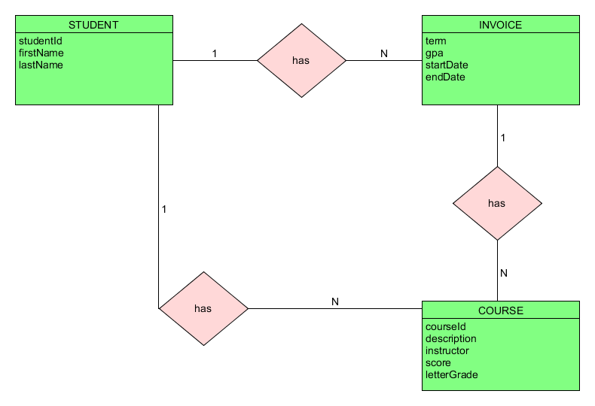

**NODETECH**

{  
 "student": {  
 "studentId": “754893”,  
 "firstName": "Gregory",  
 "lastName": "Xenophilius",  
 "enrollment": [{  
 "term": “3”,  
 "gpa": “4.0”,  
 "startDate": "11/28/2021",  
 "endDate": "01/06/2022",  
 "course": [{  
 "courseId": “235”,  
 "description": "Alchemy",  
 "instructor": "Dr. Breb",  
 "score": “89”,  
 "letterGrade": "B"  
 },  
 {  
 "courseId": “555”,  
 "description": "Intro to Herbology",  
 "instructor": "Lucia Darmila",  
 "score": “99”,  
 "letterGrade": "A"  
 }  
 ]  
 }  
 ]  
 }  
 }

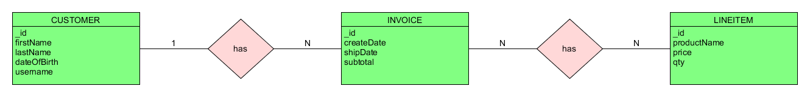

**NODESHOPPER**

{  
 "customer": {  
 "_id": 234789,  
 "firstName": "Bilbo",  
 "lastName": "Baggins",  
 "dateOfBirth": "09/22/2890",  
 "username": "cluefinder",  
 "invoice": [  
 {  
 "_id": 13412,  
 "createDate": "08/13/3001,  
 "shipDate": "08/25/3001",  
 "subtotal": “70.30”,  
 "lineItem": [  
 {  
 "_id": 54,  
 "productName": "Lava Grey Backpacking Backpack” ,  
 "price": “50.20”,  
 "qty": “1”  
 },  
 {  
 "_id": 90,  
 "productName": "Warm hat",  
 "price": “20.10”,  
 "qty": 1  
 }  
 ]  
 },  
 {  
 "_id": 75329,  
 "createDate": "08/26/3001",  
 "shipDate": "09/10/3001",  
 "subtotal": 60.00,  
 "lineItem": [  
 {  
 "_id": 93,  
 "productName": "Warm Insulated Vest",  
 "price": “50.00”,  
 "qty": 1  
 },  
 {  
 "_id": 22,  
 "productName": "Brown Bear Mittens",  
 "price": “10.00”,  
 "qty": 1  
 }  
 ]  
 }  
 ]  
 }  
}